eTenure – Submitting your Portfolio for review in OnBase
- Navigate to My Tri-C Space
  - Click the menu in the top left corner
  - Choose “Discover”
  - Navigate to the One Record / OnBase card

- Navigate in OnBase to the Portfolio Submission
  - Top left corner, change the WorkView drop down to New Form
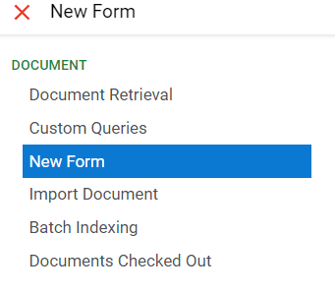
  - Choose “FAC” Portfolio Submission
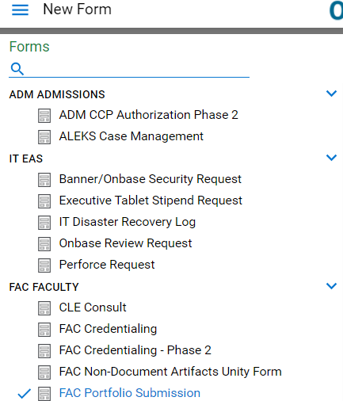
  - A new form will open up.

- Form Submission
  - The new form will capture your logged-in information. Please confirm all information is correct in the “Faculty Information” section.
  - Enter your BrightSpace Tenure Course Site URL. This will be used by the system to provide access to the reviewers to your portfolio course site.
  - Enter the email address of the Dean who will be reviewing the portfolio as the first step in the process. If a valid email address is entered, the S# for that individual will autofill.
  - Check the box confirming you are ready to submit your portfolio course site for review. This will remove your access to the course site when submitted.
