Migrations Options: eTenure Portfolio

# Quick Summary

This document will discuss the various options that faculty may use to migrate their eTenure content from Blackboard to Brightspace.

# Requesting an eTenure site for Brightspace

The following steps show how to request an eTenure site for Brightspace. All tenure track faculty must create an eTenure site in Brightspace.

## Navigate to the Tenure and Promotion page on the Tri-C website

The form that faculty will use to request their eTenure site is housed on the Tri-C website. Follow the following link to navigate to the Tenure and Promotion page.

[Tenure and Promotion page](https://www.tri-c.edu/faculty-central/faculty-promotion-and-tenure.html)

## Fill out Microsoft Form

Fill out the Microsoft Form to create your page. **Faculty will receive an email notifying them when their site is ready.**

# Migration Options

There are various options for building your eTenure Portfolio.

* Build from scratch
* Export/import from Blackboard
* Migrate using K16 service

# Option 1: Build from scratch

This option requires no migration. Faculty who choose this option must request their eTenure Portfolio, after receiving their email notification they can start to build their portfolio.

## Navigate to a section of the eTenure Portfolio to add content

Select one of the portfolio sections to add content.

eTenure Portfolio Table of Contents


## Upload Content

Select “Upload/Create” to add the needed content

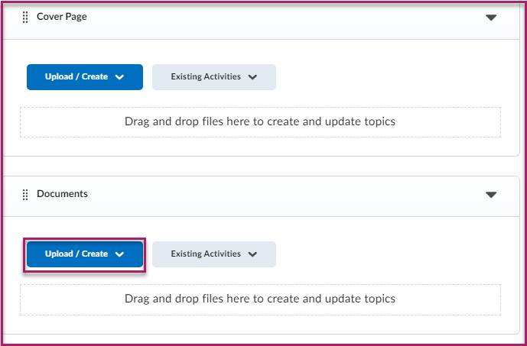

# Option 2: Export/Import from Blackboard

Faculty who already have content in a Blackboard eTenure site can export it and then import it into Brightspace. It is recommended that faculty who choose this option create a Sandbox in Brightspace to import their content to then move into their eTenure Portfolio.

## Steps for Exporting from Blackboard

Step 1. Open your eTenure Portfolio in Blackboard

Step 2. In the Control Panel, select Packages and Utilities.

Step 3. Select Export/Archive Course.

Step 4. Select Export Package.

Step 5. Select the second option for both File Attachments selections

Step 6. Choose Select All & Submit

Step 7. Navigate back to Packages and Utilities and download the Export file by clicking on the file.

## Steps for Importing into Brightspace

Step 1: Navigate to Brightspace

Step 2: Create a new Sandbox and title it eTenure Sandbox.

Step 3: Navigate to “Content” on the Navbar.

Step 4: Select Table of Contents

Step 5: Select Import Course and choose Import Course Package

Step 6: Select Upload on the pop-up window and locate your Blackboard Course Package and choose open.

Step 7: Select Import All Components.

Step 8: Navigate back to Content and check to make sure all of your content has migrated.

# Option 3: Migrate Content using K16

Faculty who choose this option will have their content moved to a Sandbox in Brightspace by the third party vendor, K16.

**If you would like to use this option, please notify David Crowell via email at David.crowell@tri-c.edu by January 8, 2025. There is no preparation needed in Blackboard for this option.**

# After Migration

For faculty who choose to have migrate their content using either options 2 or 3 their next step will be to move content from their Brightspace Sandbox to the eTenure Portfolio.

Select the following link for steps on how to move content from a Brightspace site to another Brightspace site.

[Import Selected Items from one Brightspace Course into another Brightspace Course](https://www.tri-c.edu/online-learning/technology-resources/brightspace/brightspace-faculty/documents/import-selected-items-from-one-course-into-another.pdf)

# Need Help?

If you need help with any of these processes, please email David Crowell at David.crowell@tri-c.edu.